**1.Write a program that accepts three integer values as an input. Perform summation of first two inputs which is subtracted from third input and print the result.**

**Input value: 10, 20, and 40.**

**Source code:**

#include<stdio.h>

#include<conio.h>

void main()

{

clrscr();

printf("Sum of first two values %d:",10+20);

printf("\nThe Result %d:",40-(10+20));

getch();

}

**Output:**

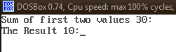

**2.Identify the reverse of given number.**

**Source code:**

#include<stdio.h>

#include<conio.h>

void main()

{

intnum,temp,rem,rev=0;

clrscr();

printf("\tName:\t\n\tRoll No.:\t\n\n");

printf("Enter the Number:\t");

scanf("%d",&num);

temp=num;

while(num>0)

{

rem=num%10;

rev=rev*10+rem;

num=num/10;

}

printf("Reverse of the %d = %d",temp,rev);

getch();

}

**Output:**

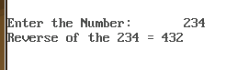

**3.How to identify a given number is prime or not.**

**Source code:**

#include<stdio.h>

#include<conio.h>

void main()

{

intnum,i,j,p;

clrscr();

printf("\tName:\t\n\tRoll No.:\t\n\n");

p=0;

printf("Enter the number\t:");

scanf("%d",&num);

if(num!=1)

{

for(i=2;i<num;i++)

{

if(num%i==0)

{

p=1;

break;

}

else

p=0;

}

if(p==0)

printf("yes, %d is a Prime",num);

else

printf("no, %d isn't a Prime",num);

}

else

printf("one(1) is neither prime nor composite");

getch();

}

**Output:**

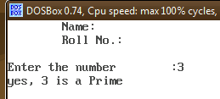

**3.How to identify a given number is Armstrong number or not.**

**Source code:**

#include<stdio.h>

#include<conio.h>

#include<math.h>

void main()

{

intnum,result=0,rem,cnt=0,temp,temp1;

clrscr();

printf("\t\tName:\t\n\t\tRoll No.:\t\n");

printf("Enter the number:\t");

scanf("%d",&num);

temp=temp1=num;

while(temp!=0)

{

temp=temp/10;

cnt++;

}

while(temp1>0)

{

rem=temp1%10;

result+=pow(rem,cnt);

temp1=temp1/10;

}

if(result=num)

printf("%d is an Armstrong number",num);

else

printf("%d is not an Armstrong number",num);

getch();

}

**Output:**

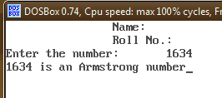

**4.Program to check whether the entered number is less than 25.**

**Source code:**

#include<stdio.h>

#include<conio.h>

void main()

{

int a;

clrscr();

printf("Enter the number:");

scanf("%d",&a);

if(a<25)

printf("%d is less than 25");

getch();

}

**Output:**

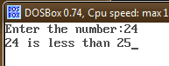

**5.Perform addition and multiplication of two numbers, if and only if the user gave two input.**

**Source code:**

#include<stdio.h>

#include<conio.h>

void main()

{

inta,b,c;

clrscr();

printf("Enter the two values:");

c = scanf("%d%d",&a,&b);

printf("Value of c is %d\n",c);

if(c == 2)

printf(" %d + %d = %d \n %d * %d = %d",a,b,a+b,a,b,a*b);

getch();

}

**Output:**

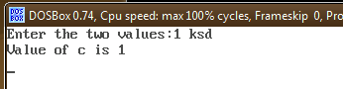

**6.program to interchange the value, if the 1st value is bigger than the 2nd one.**

**Source code:**

#include<stdio.h>

#include<conio.h>

void main()

{

inta,b,c;

clrscr();

printf("Enter the two values:");

scanf("%d%d",&a,&b);

if(a > b)

{

c = a;

a = b;

b = c;

}

printf("Values = %d\t%d",a,b);

getch();

}

**Output:**

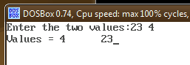

**7.program to find the biggest among 2 numbers.**

**Source code:**

#include<stdio.h>

#include<conio.h>

void main()

{

inta,b,c;

clrscr();

printf("Enter the two values:");

scanf("%d%d",&a,&b);

if(a>b)

printf("%d is greater",a);

else

printf("%d is greater",b);

getch();

}

**Output:**

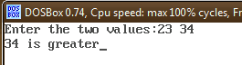

**8.program to identify whether the given number is between 10 and 20.**

**Source code:**

#include<stdio.h>

#include<conio.h>

void main()

{

inta,b,c;

clrscr();

printf("Enter the value:");

scanf("%d",&b);

if(b>=10 && b<=20)

printf("%d is between 10 & 20");

getch();

}

**Output:**

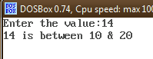

**9.Pattern generation**

**(a).**

**Source code:**

#include<stdio.h>

#include<conio.h>

void main()

{

intn,m,i,j,k;

clrscr();

printf("Enter number of rows:\t");

scanf("%d",&n);

m=n;

for(i=1;i<=n;i++)

{

for(j=1;j<=m;j++)

printf(" ");

for(k=1;k<=i;k++)

printf("%2d",k);

printf("\n");

m--;

}

getch();

}

**Output:**

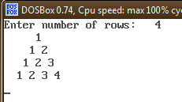

**(b).**

**Source code:**

#include<stdio.h>

#include<conio.h>

void main()

{

intn,m,i,j,k;

clrscr();

printf("Enter number of rows:\t");

scanf("%d",&n);

m=n;

for(i=1;i<=n;i++)

{

for(j=1;j<=m;j++)

printf(" ");

for(k=1;k<=i;k++)

printf("%2d",i);

printf("\n");

m--;

}

getch();

}

**Output:**

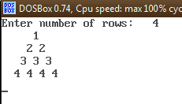

**(c).**

**Source code:**

#include<stdio.h>

#include<conio.h>

void main()

{

intn,m,i,j,k;

clrscr();

printf("Enter number of rows:\t");

scanf("%d",&n);

m=n;

for(i=1;i<=n;i++)

{

for(j=1;j<=m;j++)

printf(" ");

for(k=1;k<=i;k++)

printf(" 1");

printf("\n");

m--;

}

getch();

}

**Output:**

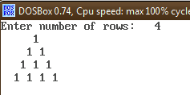

**10.Find the biggest among the given numbers.**

**Source code:**

#include<stdio.h>

#include<conio.h>

void main()

{

inti,n,a[20],max;

clrscr();

printf("Enter the Number of elements\t");

scanf("%d",&n);

printf("Enter the elements:\n");

for(i=0;i<n;i++)

scanf("%d",&a[i]);

max=a[0];

for(i=0;i<n;i++)

if(max < a[i])

max = a[i];

printf("%d is the maximum",max);

getch();

}

**Output:**

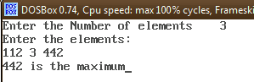

**11.Linear search**

**Source code:**

#include<stdio.h>

#include<conio.h>

void main()

{

intn,a[30],i,sr,p=0;

clrscr();

printf("Enter Number of elements:");

scanf("%d",&n);

printf("%d Number of elements:\n",n);

for(i=0;i<n;i++)

scanf("%d",&a[i]);

printf("Enter the search element:");

scanf("%d",&sr);

for(i=0;i<n;i++)

{

if(sr == a[i])

{

p=0;

break;

}

else

p=1;

}

if(p==0)

printf("%d is found at %d position",sr,i+1);

else

printf("%d is not found in the list",sr);

getch();

}

**Output:**

